Steps to create an Exe file

After creating the required batch file and downloading the appropriate softwares to accompany this exe, follow the given steps.

Step 1: Open Windows Run (Win + R) and type iexpress

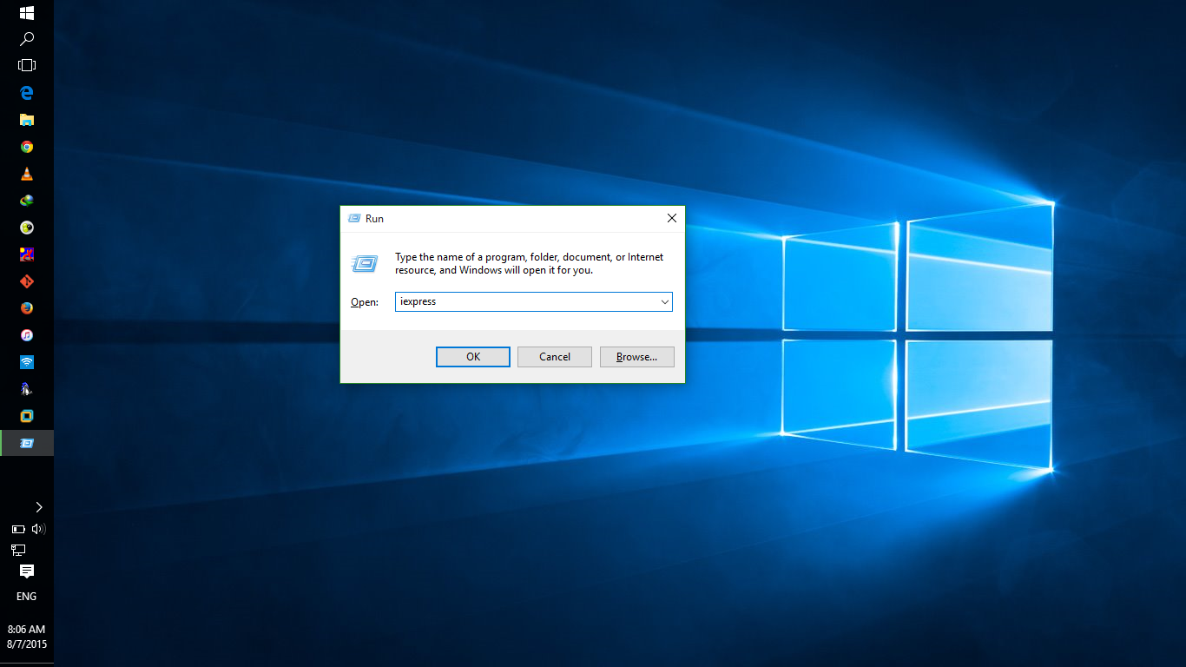

Step 2: After the setup opens, Click next

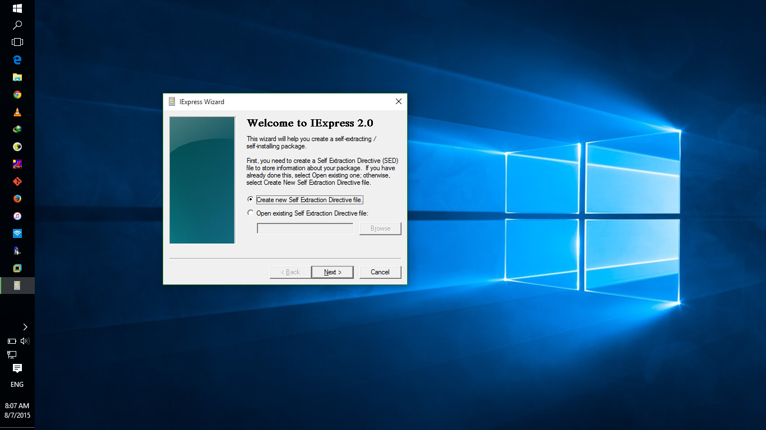

Step 3: Select the option “Extract files and run an installation command” and click Next.

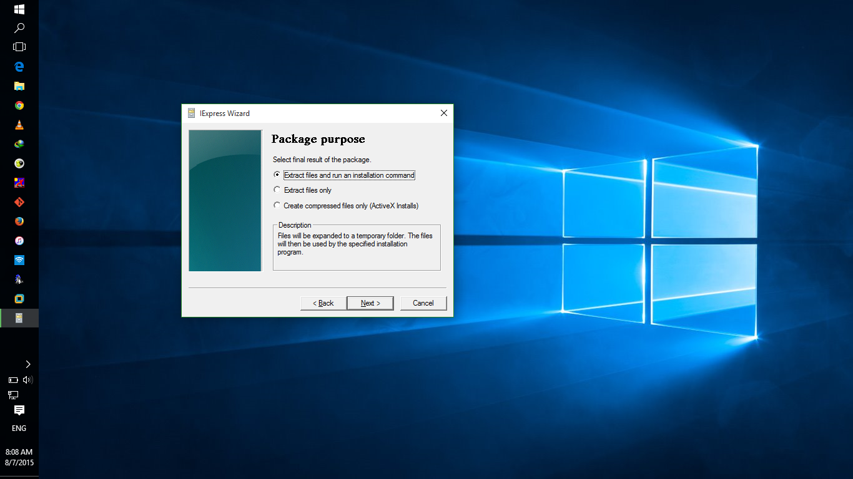

Step 4: Give the Exe file a name.

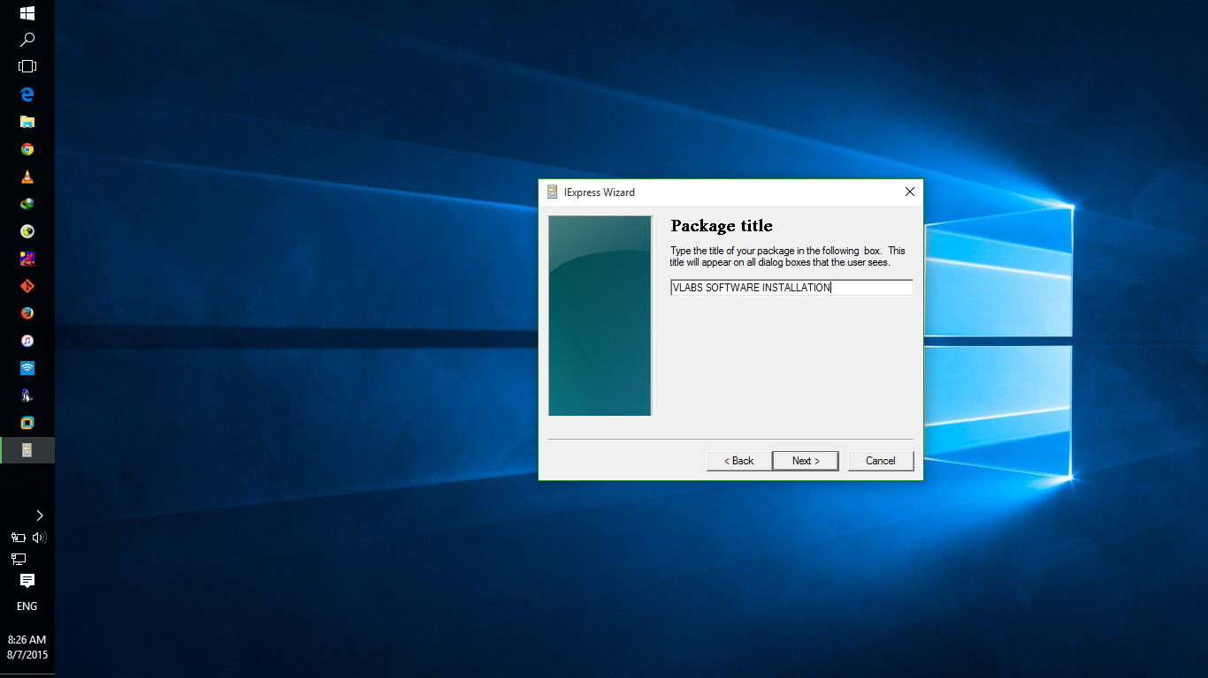

Step 5: If you want to confirm that the user wants to install your package, give them a prompt and click next.

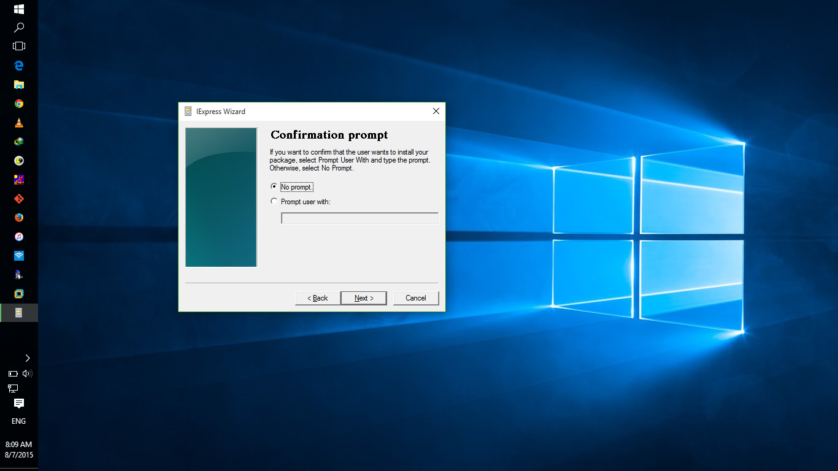

Step 6: If a license agreement has to be specified, then the required details must be given.

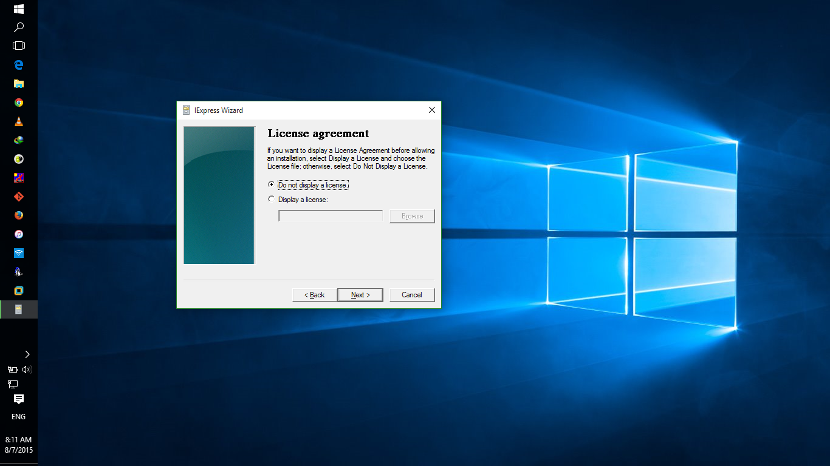

Step 7: Add all the required software packages that you need to include in your exe file, starting with the batch file program. Then click Next.

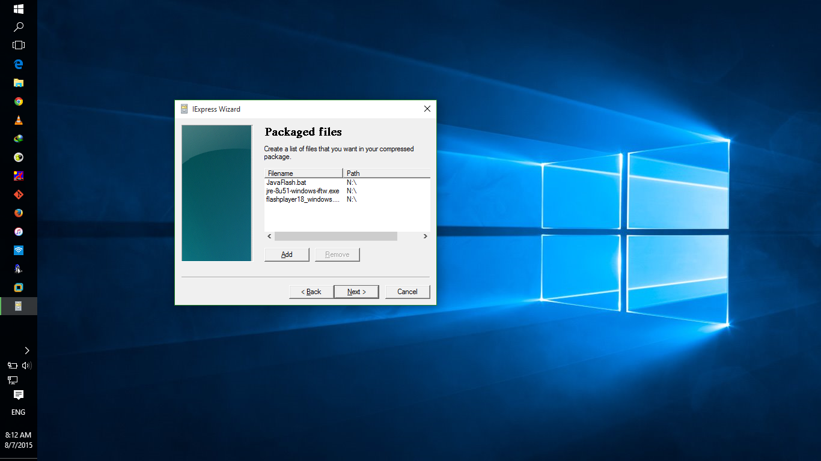

Step 8: In this step, in Install Program field type “cmd /k *filename.bat*”. This will run the setup files along with the batch file in cmd and /k option will prevent the CMD windows from closing.

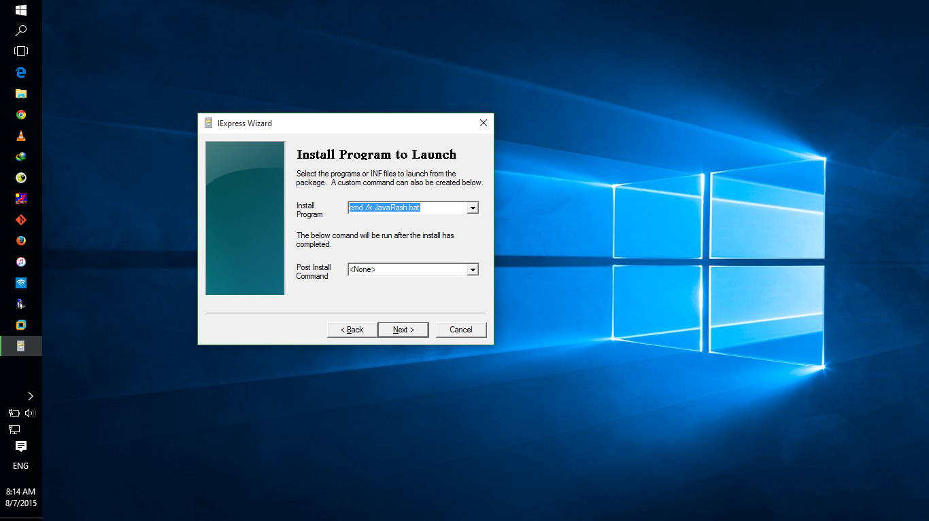

Step 9: Type in the finished message if required.

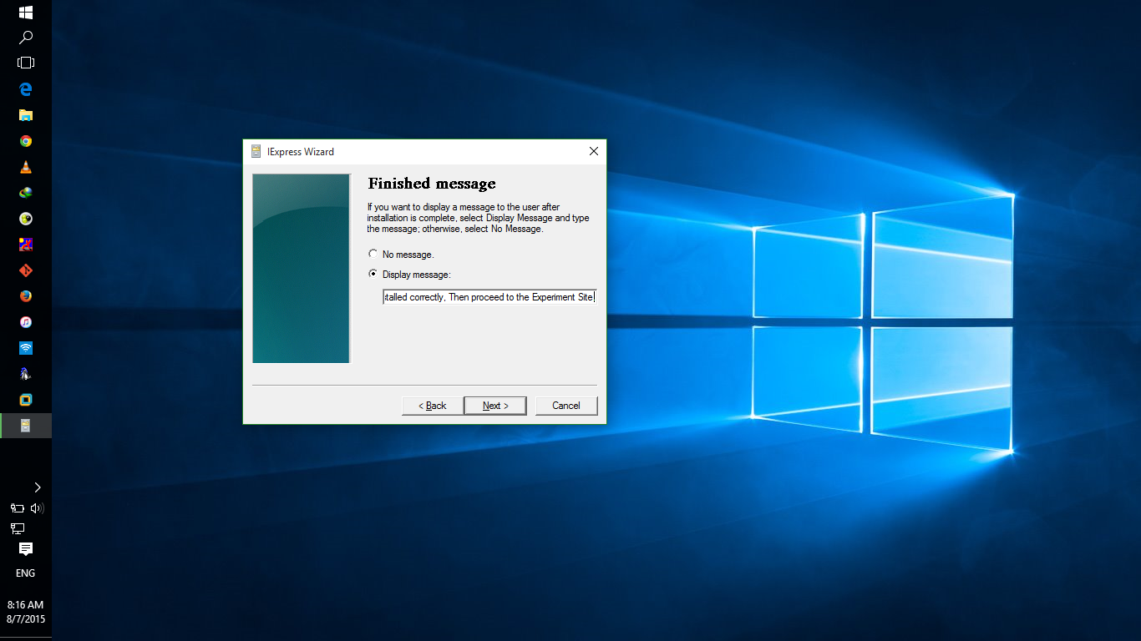

Step 10: Give the setup a name and a path.

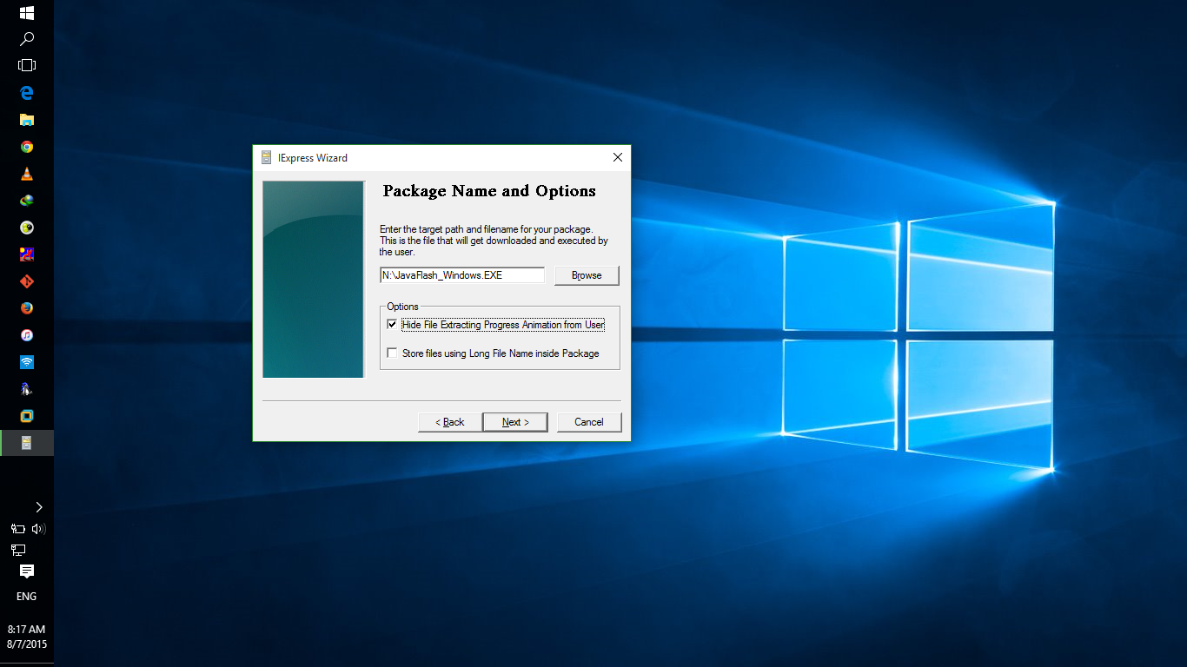

Step 11: If the any of the setups require a restart, accordingly tick the option.

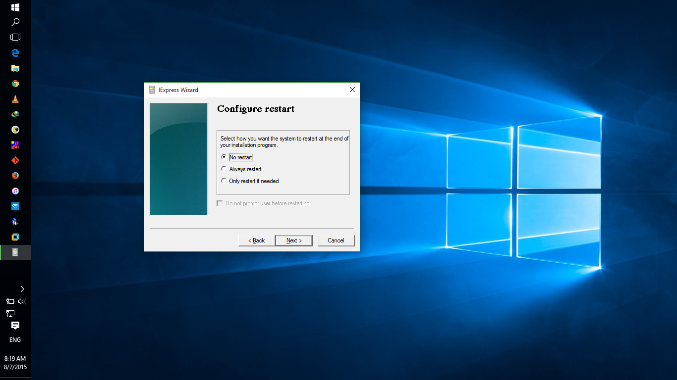

Step 11: If you would like to save the information for later use, a separate file stores all the information in a SED file. Tick if required.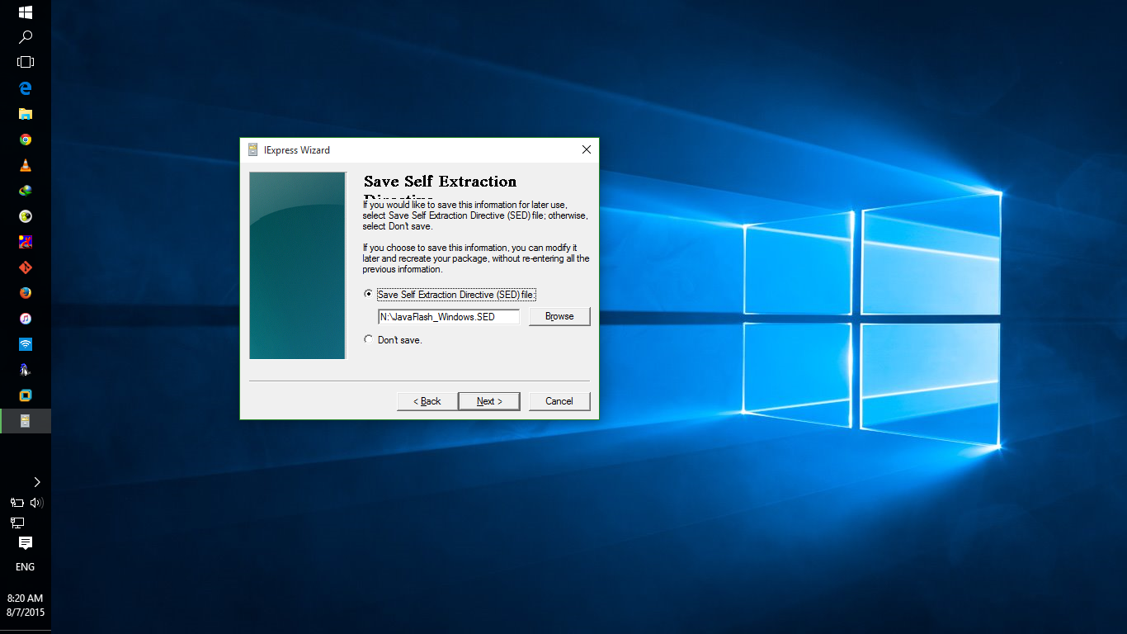

Step 12: After clicking Next Twice. The file is created. Then press Finish.

